Finding Filters
The Manage Filters page provides access to saved filters. It can be accessed from the Issue Navigator page via the 'Manage' tab at the top of the search side-bar (see Illustration 1: Issue Navigator Side-bar). The same page can also be accessed via the 'Manage Filters' menu item at the bottom of the 'Issues' drop-down menu.
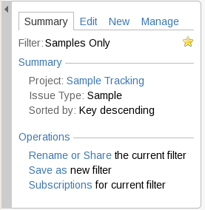
Illustration 1: Issue Navigator Side-bar
There are 4 categories of filter shown on the Manage Filters page, each has its own tab (1 in Illustration 2).
- Favorites: Filters can be set as favorites either when they are created or by editing them later. The star next to 'Favorite', in the filter's properties, is yellow when a filter is in favorites and gray when it is not. Favorite filters appear in the 'Issues' drop-down menu.
- My: All of the filters created by the current user are listed here
- Popular: These are filters that have been saved and shared by other users. Listed according to frequency of use
- Search: Finds shared filters based on their names, descriptions, who created them and how widely they are shared.
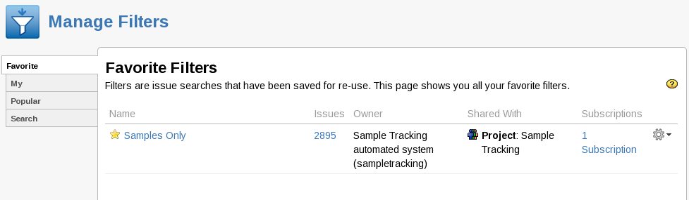
Illustration 2: The Manage Filters Page
1
2

Using, Modifying and Removing Filters
Clicking on the name of a filter returns to the Issue Navigator page and the search is carried out.
Filters can be used or modified via the image of a 'Cog' at the end of filters entry on the Manage Filter page (2 in Illustration 2). Clicking on the Cog opens a drop down menu (See Illustration 3: The drop-down Tools menu for a Filter ). From this menu it is possible to 'Edit' or 'Delete' the filter and to modify the 'Columns' displayed when it is used. Other actions are available on the Edit Current Filter page.
Filters that were created by other users cannot be modified and so do not have any links in the 'Operations' column.

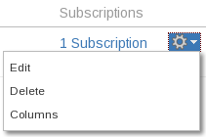
Illustration 3: The drop-down Tools menu for a Filter
The Filter management functionality is split between the drop-down tools menu, the filters entry on the Manage Filters page (Illustration 2) and the Edit page. The Edit page contains further actions in the 'Operations' section of the page's side bar (see Illustration 4: The Edit Current Filter page).
Rename or Share (Edit Side-bar), Save as (Edit Side-bar), Edit (Edit main page)
All three bring up the same page as was used for the Save Filter page. 'Save as' copies the filter creating a new filter, it does not change the original Filter. 'Rename or share' and 'Edit', however, modify the existing filter
Subscriptions (Edit Side-bar and Manage Filters)
Subscriptions are automatically run filters whose results are emailed to users (See Subscriptions on page 3).
Delete (Manage Filters)
The conformation dialog contains a count of how many subscribers there are to the filter. Do not delete a filter if there are subscribers without warning those users.
Columns (Manage Filters)
The columns displayed when viewing the results of a search/filters can be modified (by adding, removing and rearranging columns). Modifying the default column settings is covered later in the 'per Filter Column Layout' sub-section of the 'Columns in Issue Navigator' section.
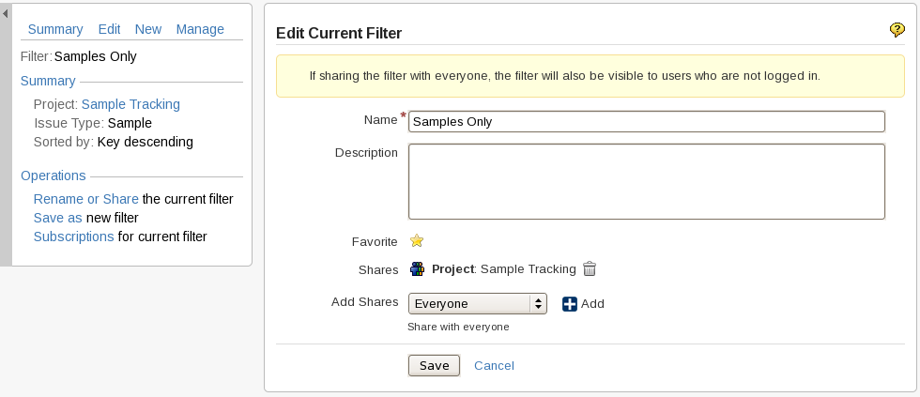
Illustration 4: The Edit Current Filter page

Subscriptions
Subscriptions are filters that are run at preset intervals and whose results are then emailed to the subscribers. Shared filters can be used, but with the following caveats:
- The creator of a filter can see all of the subscriptions using that filter
- When using a filter created by another user only the subscriptions made by the current user will be visible.
- Only the user who created a subscription can modify that subscription

Managing Subscriptions
The View Subscriptions page (Illustration 6: View Subscriptions Page) is accessed from the Manage Filters page via the 'Subscribe' / 'Subscribers' link in a filters entry (Illustration 5: Manage Filters - Subscription links). If no subscriptions are listed then the link on the Manage Filters page leads to the Create Subscription page instead of the View Subscription page.
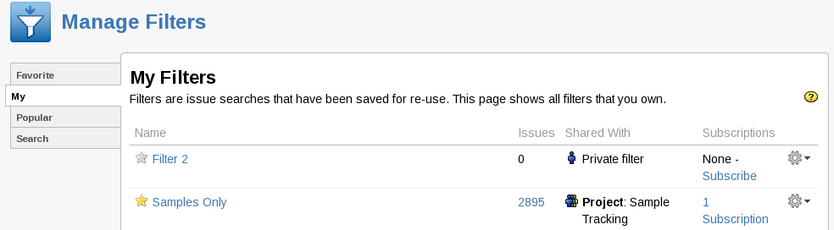
Illustration 5: Manage Filters - Subscription links
The View Subscriptions page lists a subset of the subscriptions that use that filter. (See Illustration 6: View Subscriptions Page). Links are provided to 'Create', 'Edit', 'Test' and 'Delete' subscriptions.
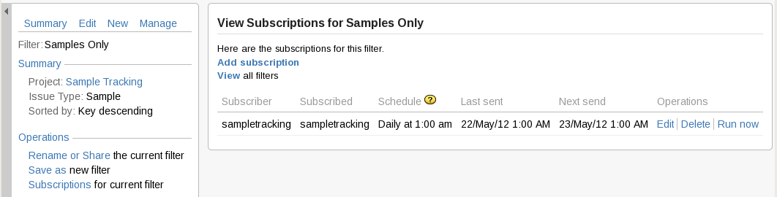
Illustration 6: View Subscriptions Page

Note:
There are two 'Operations' sections on the View Subscriptions Page. The Operations in the side-bar act on the most recently used filter and have nothing to do with subscriptions. Only the 'Operations' column at the far right, containing 'Edit', 'Delete' and 'Run now' act on the subscription.

Creating a Subscription (View Subscriptions, View Filters, Summary side-bar)
Subscriptions can be created in a number of ways:
- The 'Add Subscription' link on the View Subscriptions page (Illustration 6) .
- The 'Subscribe' link on the View Filters page (Illustration 5). This is only available on filters that have no existing subscriptions
- The 'Subscriptions' for the current filter link in the Summary tab of the Issue Navigator page's search side-bar (see Illustration 7: The Summary Tab of the Issue Navigator side-bar).

Editing a Subscription (View Subscriptions)
Editing subscriptions is only done using the 'Edit' link in the operations column of the View Subscriptions page.
Both creating a subscription and editing a subscription bring up the same Filter Subscription page (Illustration 8: Manage Filters - Create Subscription).

Deleting a Subscription (View Subscriptions)
The 'Delete' link in the operations column of the View Subscriptions page removes the subscription without presenting any warning dialog. Be careful not to press this by accident as there is no undo either.

Testing a Subscription (View Subscriptions)
The 'Run now' link in the operations column of the View Subscriptions page causes the subscription email to be sent as though the scheduled time had been reached. This does not reset the schedule. The email may take several minuets to be sent and received.

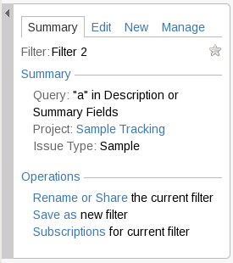
Illustration 7: The Summary Tab of the Issue Navigator side-bar
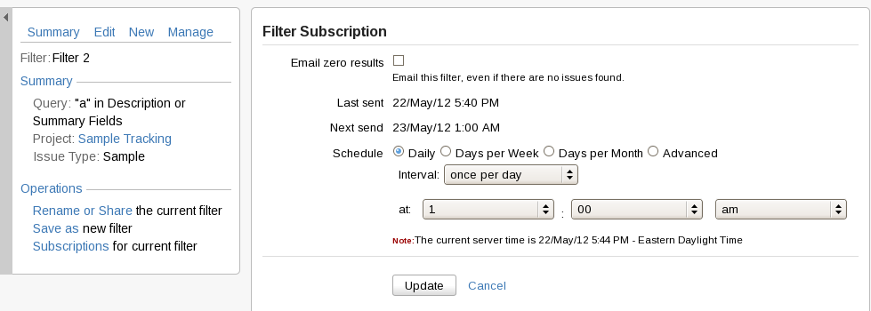
Illustration 8: Manage Filters - Create Subscription
The Filter Subscription page allows customization of when the subscription's filter is run and if an email should be sent when there are no matches found (Illustration 8: Manage Filters - Create Subscription). Again the side-bar is for the most recently used filter and has nothing to do with subscriptions.

The creator of the filter cannot edit or delete individual subscriptions on a filter but they can delete the filter which in turn deletes all of the subscriptions that were based on that filter.

